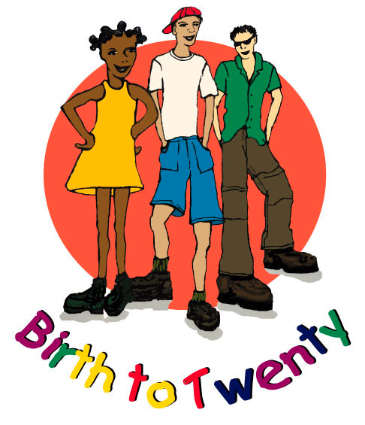

University of the Witwatersrand

Department of Paediatrics and Child Health

BIRTH TO TWENTY MEDICAL SCHOOL SITE: 16TH YEAR
ADOLESCENT QUESTIONNAIRE

DATE : Day Month Year

BTT ID NUMBER :

BONE STUDY ID NUMBER :

Consent Table | Yes | No
Questionnaire (Bt20 Services)

Self – Complete Questionnaire

Anthropometric Measurements

Pubertal Assessment

Adolescent DXA

Adolescent pQCT

Adolescent Urine

Adolescent Blood

INFORMED CONSENT

I agree to myself being a participant in the Birth to Twenty study.

The goals and methods of Birth to Twenty are clear to me.

I understand that the study will involve interviews, measures of growth, literacy and numeracy tests, educational development and school reports. All the details and purposes of these tests have been explained to me. I understand that I have the right to refuse to participate in the study.

I, the undersigned, hereby declare that I understand:
1. That the University of the Witwatersrand, Johannesburg (hereafter referred to as “the University” has insured itself against the acts and omissions of persons acting on its behalf insofar as it is liable in law therefore and that its registered students and staff are insured during the course and scope of their registered courses and/or within the scope of the University business, where the fault can be attributed to the University or its affiliates.

2. That in cases where no fault can be attributed to the University, I hereby indemnify, absolve and hold harmless the University, its officials, employees, students and invitees in respect of any damage to the property, death or bodily injury to/of myself and/or third parties, whether on/off the University precincts, or whilst engaged in any activity related to the University.

3. And undertake, for any period during which I am on the university precincts or during my participation in the Birth to Twenty Study, to be bound by the rules and regulations of the University for the time being in force and by any requirements or conditions imposed by the University on me.

I agree to participation in the study on the condition that:

1. I can withdraw from the study at any time voluntarily and that no adverse consequences will follow on withdrawal from the study.

2. I have the right not to answer any or all questions posed in the interviews and not to participate in any or all of the procedures / assessments.

3. The Committee for Research on Human Subjects at the University of the Witwatersrand has approved the study protocol and procedures.

4. All results will be treated with the strictest confidentiality.

5. Only group results, and not my/my child’s individual results, will be published in scientific journals and in the media.

6. The Bt20 scientific team are committed to treating participants with respect and privacy through interviews conducted in private and follow-up counselling available on request.

7. I will receive a referral note to a health service if any result is out of the normal range or a problem is detected in the course of the study.

I understand that I attend and participate in Birth to Twenty on the (date)________________ at my own risk where the event falls outside the cover provided by the University. I acknowledge that I have read and understood the contents of this informed consent and indemnity in every respect

Youth participant ________________ Research Assistant ___________________
There are 7 components that we are going to work through together; it will take about 2 hours

In this section of this questionnaire is about the Bt20 Health Services

At Birth to Twenty we are concerned with the health and wellbeing of our study participants. We have in the past offered services to both adolescents and caregivers, such as counseling as well as testing for cholesterol and diabetes. We have had many requests for other tests and we would like to ask you a series of questions around the Bt20 health service.

Question 1
Would you like Bt20 to continue to offer the following free services/tests/monitoring to you?
 | YES | NO
Counseling
Cholesterol
Diabetes
High Blood Pressure

Question 2
Would you like Bt20 to offer the following free services/tests to you in the future?
 | YES | NO
Heart disease
Cancer/tumors
Pregnancy
Sexually transmitted infections
HIV counseling and testing

Question 3
Would you like to give consent (permission) to the following tests independently of your parent/caregiver?
 | YES | NO
Heart disease
Cancer/tumors
Pregnancy
Sexually transmitted infections
HIV counseling and testing

Question 4
Do you think it is easier (more convenient, more private) to answer questions around smoking, drugs, sex by yourself at HOME or at the BT20 site offices?
(Please tick only ONE)
It is easier at HOME
It is easier at the Bt20 site office
Both are equally the same

Research Assistant name: Date:

ADOLESCENT MEASUREMENTS
ANTHROPOMETRY
- STANDING HEIGHT: (mm)
- SITTING HEIGHT: (mm)
•
- WEIGHT: (kg)
- WAIST CIRCUMFERENCE: (mm)
- HIP CIRCUMFERENCE: (mm)
- SHOULDER-ELBOW: (mm)
- ELBOW-WRIST LENGTH: (mm)
- THIGH LENGTH: (mm)
- CALF LENGTH: (mm)
- BICEP GIRTH: (mm)
- BIEPI BREADTH HUMERUS (mm)
- BIEPI BREADTH OF FEMUR (mm)
- CALF GIRTH: (mm)

SKINFOLD MEASUREMENTS – LEFT SIDE (mm)
•
•
•
•
•
•
•
•
•
•
•
•
- TRICEP:
- BICEP:
- SUBSCAPULAR:
- SUPRA-ILIAC:
•
•
•
- MEDIAL CALF

Research Assistant name: Date:

FLEXIGRIP
R
L
- NON-DOMINANT HAND: OR

•
•
•

Research Assistant name: Date:

BLOOD PRESSURE

- SYSTOLIC BP

- DIASTOLIC BP

- PULSE
h
- TIME OF BP

Research Assistant name: Date:

BONE SCANS

Y

N

DXA scan

Y

N
- PQCT

Operator name: Date:

COLLECTION OF SPECIMENS

Y

N
- Urine 1

Y

N
- ROUTINE BLOOD SAMPLE

Lab Assistant’s name: Date:

PUBERTAL ASSESSMENT and SELF COMPLETION

Y

N
- Pubertal assessment Questionnaire

Y

N

- Self completion Questionnaire

Research Assistant name: Date:

BONE AGE X-RAY

Y

N

Quality checked by: Date:

NOTES

